control flow diagram

Exercise 1

With space (only for under standings)
1. void main() {
2. int i, j, k;
3. readln(i, j, k);
4.
5. if ((i < j) || (i > k)) {
6. writeln("then part");
7.
8. if (j < k)
9. writeln("j less than k");
10. else
11. writeln("j not less than k");
12. } else {
13. writeln("else Part");
14. }
15. }
Without space (for use in graph creation)
1.void main(){
2.int i,j,k;
3.readln(i,j,k);
4.if((i<j)||(i>k)){
5.writeln("thenpart");
6.if(j<k)
7.writeln("jlessthank");
8.else writeln("jnotlessthank");
9.}else writeln("elsePart");
10.}
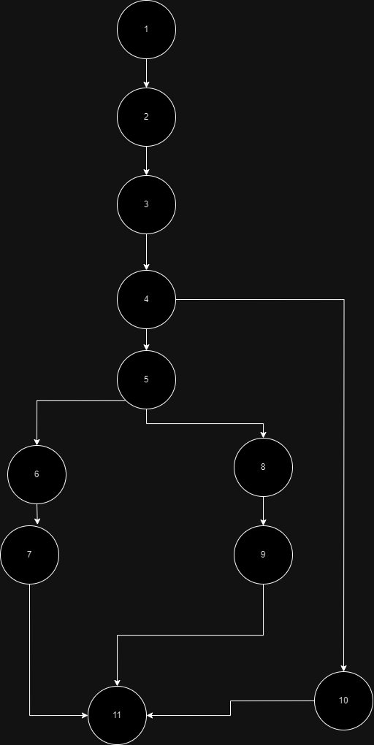
Number of Edges in given flow graph is 12
Number of Node’s in given flow graph is 11
Number of Node that have exit points is 1
=E-N+2*P
=12-11+2(1)
=4

Example 2

1. i = 0;
2. n = 4; // N-Number of nodes present in the graph
3. while (i < n - 1) do
4. j = i + 1;
5. while (j < n) do
6. if A[i] < A[j] then
7. swap(A[i], A[j]);
8. end do;
9. i = i + 1;
10. end do;

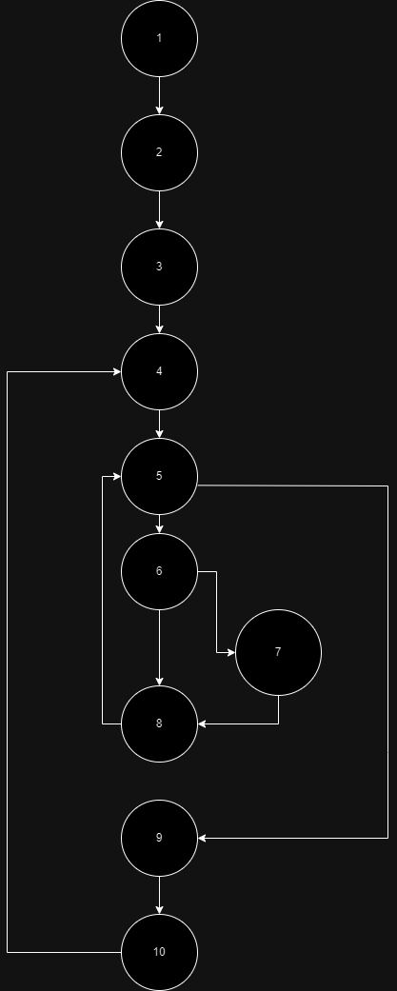
Number of Edges in given flow graph is 12
Number of Node’s in given flow graph is 10
Number of Node that have exit points is 1
=E-N+2*P
=12-10+2(1)
=4

